Intelligent all-round gimbal

User manual

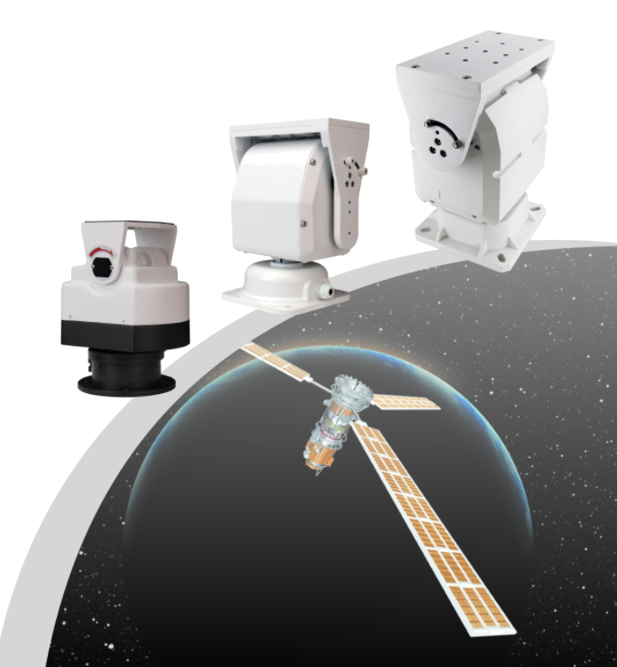

1. Overview:
The intelligent all-round gimbal uses a stepper motor, and the horizontal and vertical automatic limit adjustment. Aluminum alloy molded casting, high temperature resistance, aging resistance, corrosion resistance, waterproof.
The internal single-chip microcomputer design is adopted, and the preset position call and line scanning function are realized, which is convenient for customers to operate remotely.
This manual provides detailed installation methods and installation steps, the installer must have a detailed understanding of the building structure of the installation location, and a detailed understanding of the installation technical requirements, and correct installation to achieve the best use effect and safety of this product.
2. Technical parameters
Item No. | 303 | 3050 | 3055
Power Supply | DC12V 5A；AC24V 3A（选配）
Ambient temperature | -25℃～+50℃
Ambient humidity | ≤95% No condensation
Communication control mode | RS-485 half-duplex bus
protocol | Pelco-D/Pelco-P Adaptive
Address code range | 0～64
Horizontal rotation angle | 0～350° | Max. 350°
Vertical rotation angle | -32°～+23° | Max.-70°～+20°
Rotation speed | Horizontal14°/S；Vertical2°/S
Two-point line sweep speed | 7～14°/S
Preset point cruise | Two sets of programmable automatic cruise trajectories, each consisting of 16 points
Data power-off memory function | When the omnidirectional camera is in the running line scan or trajectory cruising state, it will be powered back on after a sudden power failure, and the omnidirectional camera will automatically run again to maintain the state before the power failure.
Matching wires | Wires larger than 0.5 mm² (5 m distance)

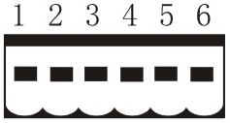
3.Gimbal installation connection：
Control the input plug： Linker

Connecting DC12V
- DC12V+
- DC12V-
- RS485+
- RS485-
- AUX
- AUX

AC24V
- AC24V
- AC24V
- RS485+
- RS485-
- AUX
- AUX

Schematic diagram of the function：
12V+ | 12V- | 485+ | 485- | AUX | AUX
Red | Black | orange | yellow | green | blue
1 | 2 | 3 | 4 | 5 | 6
1. Rotation angle limit
2. Control the input socket
3. Bracket holder
4. Qualify
5. Address Protocol Dialing

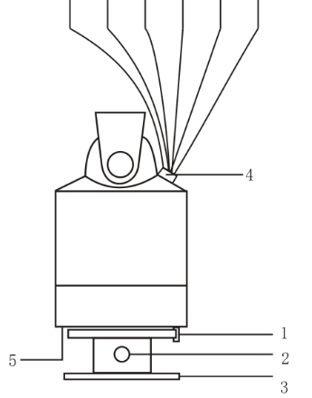

DIP switch
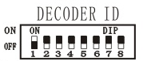

baud rate
Address
code
2
Description of the outgoing function:
1.2-pin DC12V output, maximum current 1.5A, can provide stable power supply for camera fill light, etc.
3.4-pin is used for network equipment with 485 output, and the function is the same as that of the bottom input
5.6-pin normally open auxiliary switch, used to control the on/off of other equipment such as fill light wipers
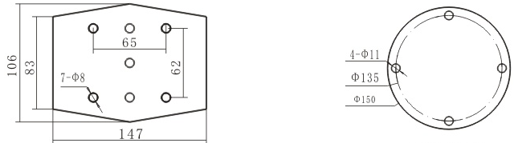
Installation diagram：

303 Camera mounting plate 303 base
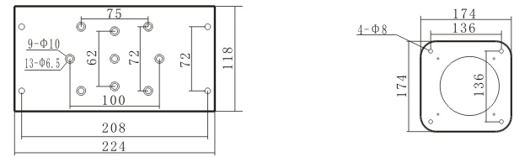

3050 camera mounting plate 3050 base
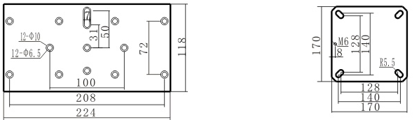

3055camera mounting plate 3055 base
4.Address setting：（DIP switches 1-6 are set for the address code）
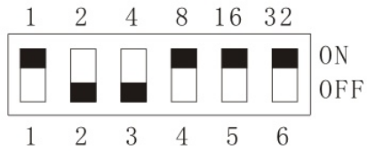
The address code is a 6-bit binary code, which corresponds to the sum of the ON positions of each DIP switch, and the total number can be set to 64 channels. For example, if there are 57 channels, the corresponding bits of 57 = 1 + 8 + 16 + 32 are set to ON, AND PELCOD-D/PELCOD-P protocols are adaptive.

- Baud rate setting (DIP switch 7-8 is set for baud rate)
DIP settings | Baud rate | DIP settings | Baud rate
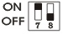 | 1200 | 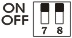 | 4800
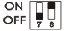 | 2400 | 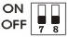 | 9600

5.Preset setting and call
Preset | function | Instructions
17 | Sets the left starting point of the limit scan | Set the 17th preset point
18 | Sets the right starting point of the limit scan | Set the 18th preset point
19 | Start a limit scan | Call the 19th preset point
22 | Set the line scan speed to 5<N<13 | Set the 22nd preset point  Set the N preset point
70 | The cruise stay time is 5 seconds | Call the 70th preset point
71 | The cruise stay time is 10 seconds | Call the 71st preset point
72 | The cruise stay time is 15 seconds | Call the 72th preset point
89 | Start the maximum angular line scan | Call the 89th preset point
83 | Start the first cruise preset points 1-16 | Call the 83rd preset point
84 | Activate the second cruise preset points 33-48 | Call the 84th preset point
110 | The guard position is opened, and after no operation until the homing time, go to the No. 1 preset point | Set the 110th preset popint
110 | Guardhouse Off: Closed by default | Call the 110th preset point
111 | The homekeeping time of the guard position is set to 29<N<251 seconds, and the factory default is 60 seconds | Call the 111st preset point+ call the N preset point
120 | Eliminate all preset points | Call/set the 120 preset point
125 | Restore the default parameters to start the gimbal self-test | Call the 125th preset point
105 | Turn off the gimbal self-test | Set the 105th preset point
105 | Enable gimbal self-test by default | Call the 105th preset point

6. Connection method and terminal resistance
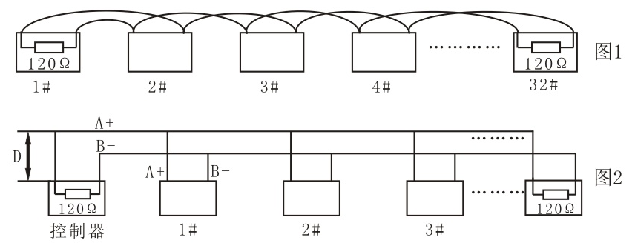
The RS485 industrial bus standard requires a daisy chain connection between the devices. There must be 1202 terminal resistors at both ends, (as shown in Figure 1): Figure 2 can be used for simplified connection, but the distance of the "D" segment shall not exceed 7 meters, and the terminal resistors must be connected to the equipment with the farthest distance from the line. See Figure 2

4

7. Precautions and maintenance:
1) Pay attention to the power supply voltage marked by the gimbal, and never plug in high-voltage electricity, otherwise it will burn out the equipment
2） The horizontal rotation of the gimbal shall not exceed 360°, otherwise it will cause the failure caused by the winding of the internal wiring.
3） Please do not leave the gimbal in automatic working mode for a long time.
Common faults:
A. The gimbal does not work when powered on
Cause: The working power supply is not connected or is connected incorrectly
B. The decoder cannot be controlled
Reason: The polarity of the decoder communication control line is reversed;
decoder control protocol error;
The decoder communication baud rate is incorrect;
The address code of the decoder is wrong (whether the address code switch setting is consistent with the address of the camera controlled by the host: (some host camera No. 1 is the address, and the host camera No. 0 is the address 1) The communication line is too long or the signal is too weak, and the resistor is not added according to the regulations.
C. Power on for a while, can not be controlled
Cause: The operating voltage is too low or the input line is too long
D. It cannot be controlled after operating the DIP code, and the power should be restarted.

